**7. Write a program to perform K means clustering**

**Description:** This experiment illustrates the use of simple k-mean clustering with Jupyter Notebook. The sample data set used for this example is based on the iris data available in ARFF format. This document assumes that appropriate pre-processing has been performed. This iris dataset includes 150 instances.

**Code and Output:**

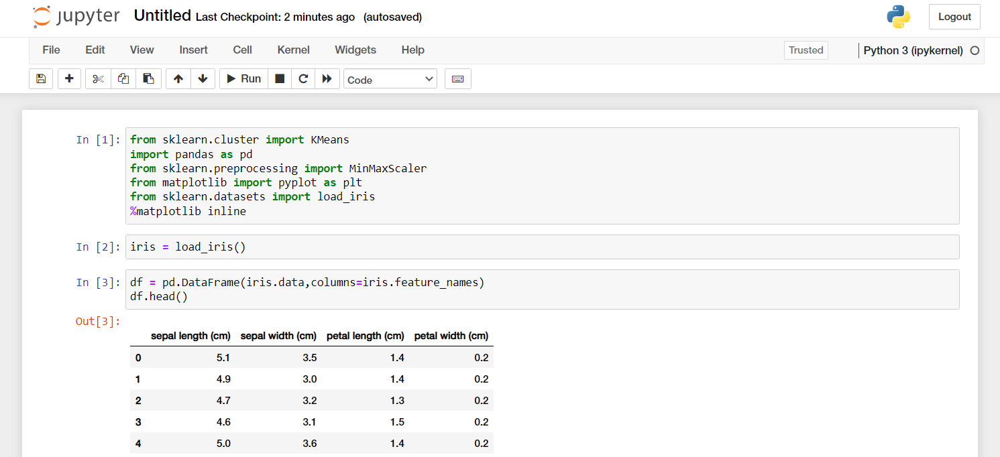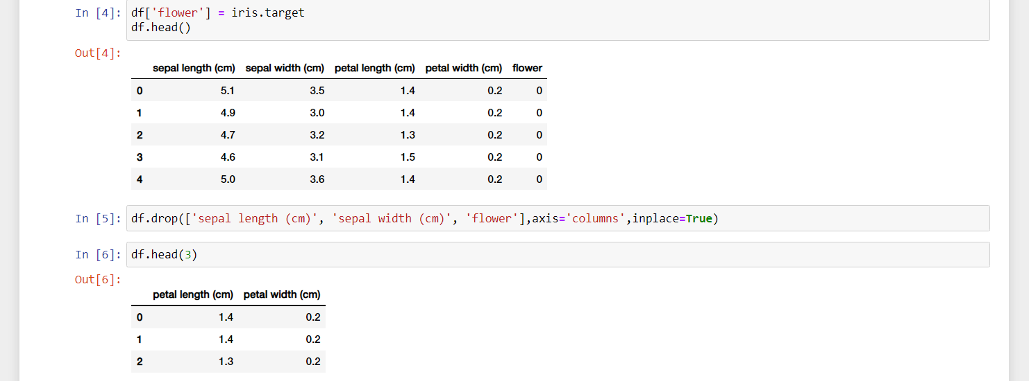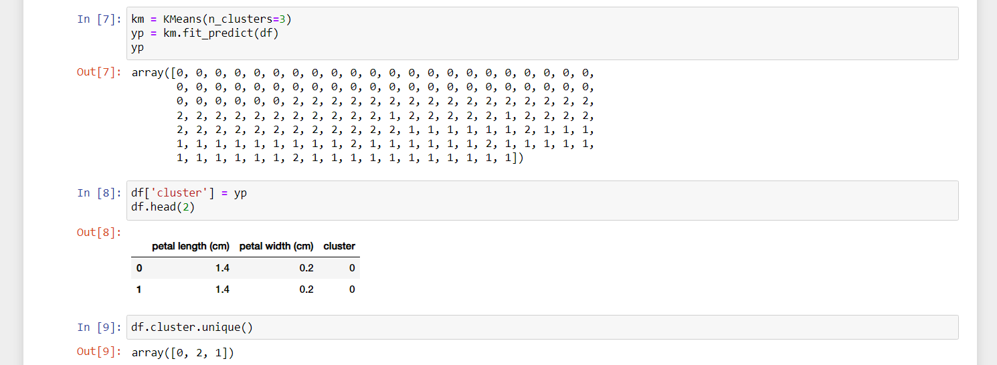

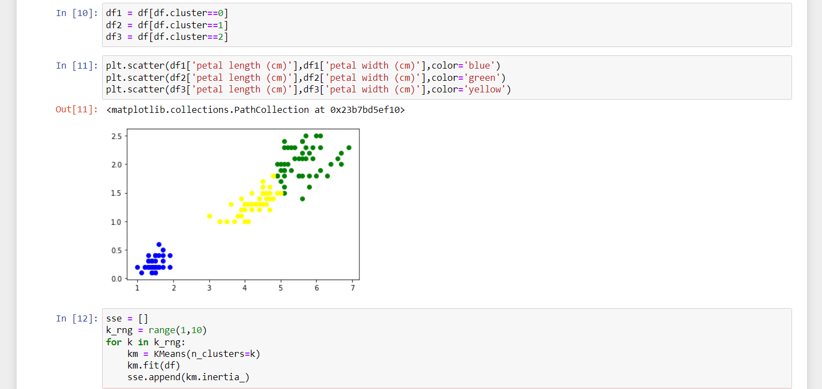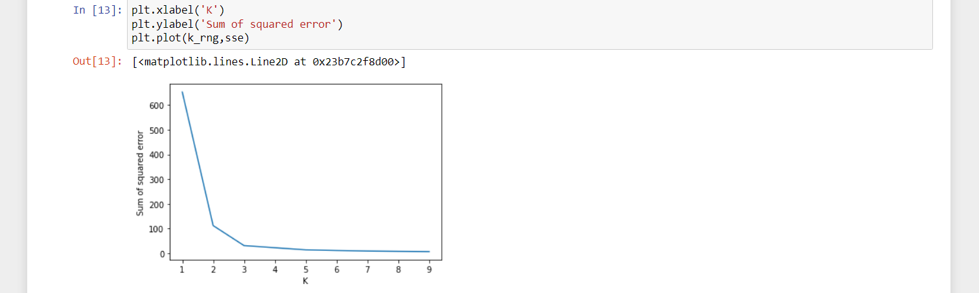

We also drew the elbow plot and figured out that the optimal k value is 5.